

the History game

PGKPI

Contents

A. Who we are: 2

B. Purpose: 2

C. Future plans: 2

D. Structure of the site: 2

# Who we are:

Vasil Todorov Stanchev

[VTStanchev18@codingburgas.bg](mailto:VTStanchev18@codingburgas.bg)

Georgi Kaloyanov Georgiev

[gkgeorgiev18@codingburgas.bg](mailto:gkgeorgiev18@codingburgas.bg)

Ivo Miroslavov Dimov

[IMDimov18@codingburgas.bg](mailto:IMDimov18@codingburgas.bg)

Martin Todorov Bakalov

[MTBakalov18@codingburgas.bg](mailto:MTBakalov18@codingburgas.bg)

Nikolai Petrov Brankov

[NPBrankov19@codingburgas.bg](mailto:NPBrankov19@codingburgas.bg)

# Purpose:

History is one of the less interesting subjects in school for some kids, so the goal of the game is to make it more interesting and entertaining for children to study history in a way that they find way more attention-grab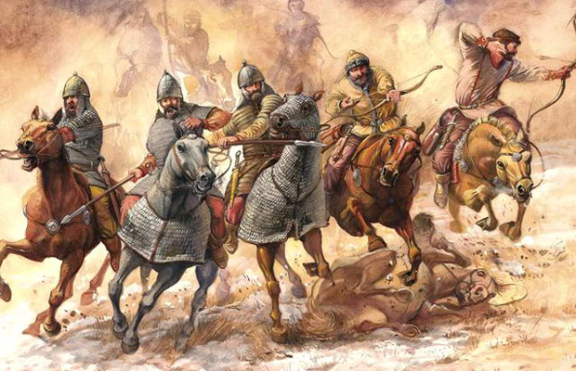bing.

# Future plans:

Some of our future plans include: Adding different languages for the game and the site as well as adding more Bulgarian rulers to the game.

# Structure of the site:

|  |  |
| --- | --- |
| Home | There you can find some information about the game. |
| Game | There you can find the game itself along with instructions how to play it. |
| Feedback | There you can contact us if you have a quastions or to report problems with tha game. |

This is our main page.

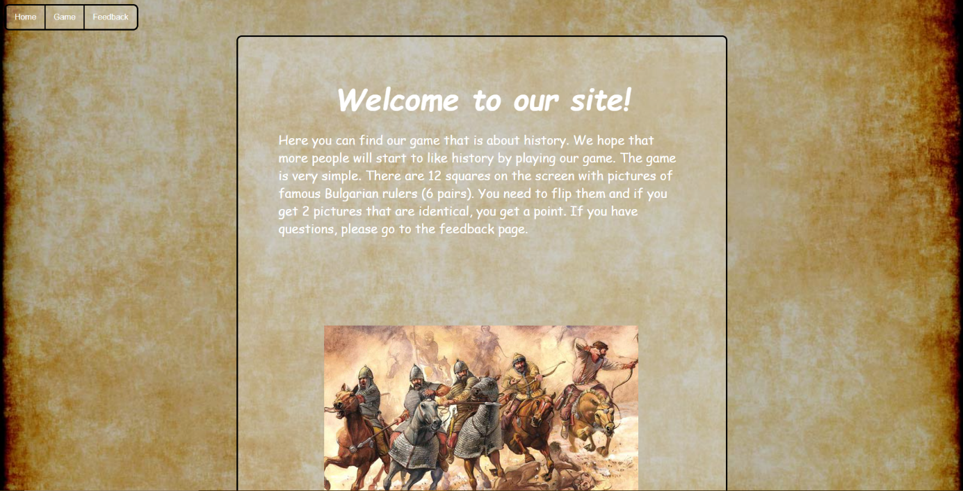

This is the game.

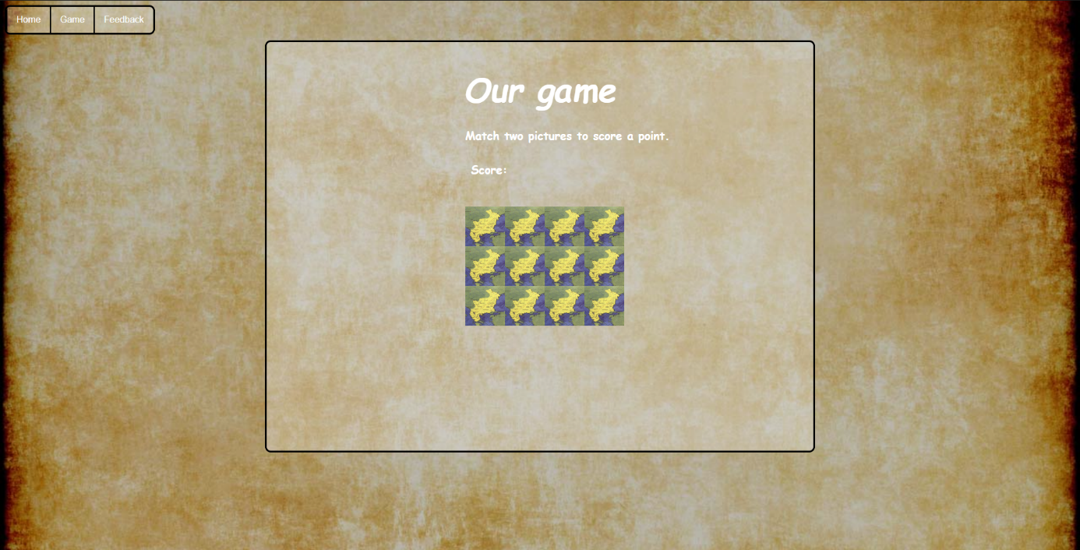

This is our feedback page.

